LIHTC Model

Data:

Source:
- INSURED MULTIFAMILY MORTGAGES DATABASE: The data source we use to label the LIHTC status of the GPL loans (https://www.hud.gov/program_offices/housing/comp/rpts/mfh/mf_f47/). This data source:
  - Identifies the status of “receiving Tax Credit” and “using Tax-Exempt Bond” of each GPL loan based on FHA Number / Pool Number
  - The table updates monthly with the latest status of the loans
  - We keep records of all historical updates in our database
- LIHTC Database: A secondary data source for additional information about the LIHTC properties (https://www.huduser.gov/portal/datasets/lihtc.html). This data source:
  - Provides detailed information, including “LIHTC allocation year (alloc)”, “placed in service (pis) year”, “for-profit/non-profit flag”, which are useful dimensions for understanding the LIHTC loans’ prepay behaviors.
  - Is property-based and doesn’t have any loan ID (FHA number or Pool number). Therefore, to match the records with our GPL loan table, we have to use the property name and geo information (with proper data cleaning) with approximation.

Size:
- Assumption: We use all “non-CL, in-deal” pool prepay information since 2014-03 for modeling
- Magnitude: Each level is a subset of the previous
 | Dataset # | # Loans | # Data Points (k) | Total Balance ($bn)
All GPL  (non-CL, in-deal) | 1 | 18,000 | 682 | 5,000
Within Dataset #1, Loans with TC/TE * labeling | 2 | 1,748 | 57 | 440
Within Dataset #2, Loans with LIHTC | 3 | 1,699 | 56 | 416
Within Dataset #3, Loans with Valid “PIS / alloc year” ** | 4 | 1070 | 38 | 243
Within Dataset #4, Non-Profit LIHTC | 5 | 148 | 5 | 30
Within Dataset #4, For-Profit LIHTC | 6 | 769 | 26 | 181
* TE means if a property is receiving tax-exempt bond as funding. This is different from Tax-Credit (TC). TE status, however, can be used in conjunction with TC status to tell the type of credit percentage: A property with both TC & TE receives 4% LIHTC, whereas a property with TC only receives 9% LIHTC.
** Based on current property matching algorithm. The number of data points may potentially improve if we further refine the algorithm

Quality:
- INSURED MULTIFAMILY MORTGAGES DATABASE (IMMD):
  - Certain historical loads are bad (1/10/2018, 11/15/2018, 1/7/2019). Inconsistent results compared with datasets from adjacent loading dates. Therefore, we need a database check script to examine the magnitude of TC status change every month before we load in new data from HUD.

- LIHTC database (TC):
  - Updates once a year, with a 1-3 year lag
  - Latest update is Jun 2018
  - Summary of missing data: https://lihtc.huduser.gov/missing.htm
    - Allocation Year: Historically around 2~3%, higher for recent records.
    - Nonprofit Sponsorship: Around 10-20%.
    - Property Address: Around 1% for recent records, >5% prior to 1992.

- Integrating IMMD and TC: By definition, IMMD is a subset of the GPL Universe. In theory, loans from IMMD (issued prior to 2016) should be contained by TCD. With the current matching method, however, only a little more than half of the loans from IMMD has a match from the TCD. On the other hand, there are also loans matched in TCD but not found in IMMD. Hence, neither IMMD nor TCD has a complete labelling for LIHTC properties. For more accurate labelling and better model training, we need to combine the 2 datasets.
  - Data Relationship Chart: The data can be divided into 5 areas. The scope of this study is the combination of area “B”, “C”, & “D”.
    - Area A: Loans neither labelled as “TC” nor found in “LIHTC Database”. These are the loans not in the scope of this model update.
    - Area B: Loans labelled as “TC”, but not found in “LIHTC Database”. These are the loans that we cannot rely on the additional information from “LIHTC Database” for modeling.
    - Area C: Loans both labelled as “TC” and have “LIHTC Database” matching. These are the loans that we can rely on the additional information from “LIHTC Database” for modeling.
    - Area D: Loans not labelled as “TC” but have matchings from “LIHTC Database”. These loans exhibit similar prepay pattern as the “TC” loans, and are also over-projected by the original GPL model. Hence, we treat those loans as “TC” as well.
    - Area E: Properties don’t have any FHA-insured loan found. Out of scope.
GPL Universe
“Area A”
GPL loans
labelled with “Tax Credit”

“Area B”

LIHTC Properties Database
“Area E”
“Area C”
“Area D”

Hypothesis and Observation:

General Characteristics:
- Data Overview (S-curve): Both incentive-driven & non-incentive-driven prepayments are slower than normal GPL loans.
  - Dataset #1: Actual CRR (All GPL loans) vs Penalty-Adjusted Incentive
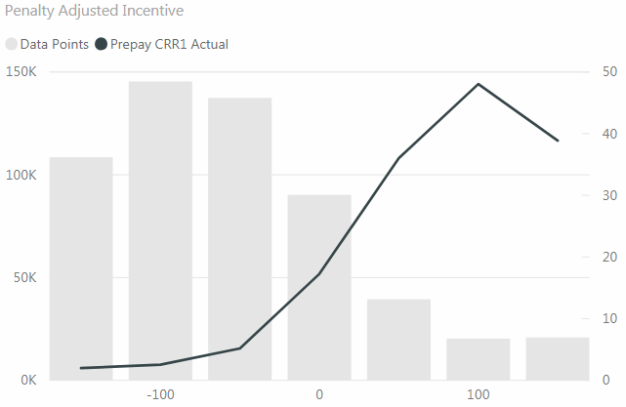
  - Dataset #3: Actual CRR (LIHTC loans) vs Penalty-Adjusted Incentive
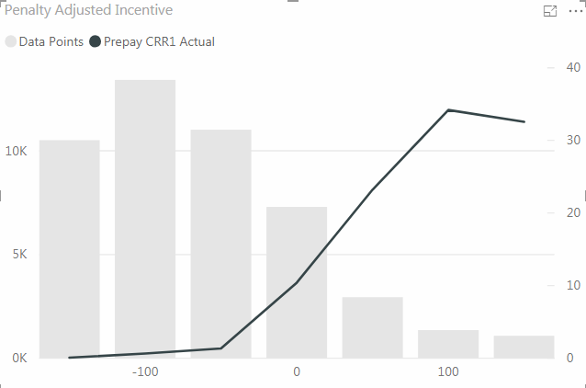
- Incentive-driven Prepay (Refi):
  - There is Incentive driven refinance for LIHTC loans both before & after year 15. Sometimes the original GP of a LIHTC property will have refinanced before Year 15 to take advantage of better financing terms such as lower mortgage interest rates (pp.51 What happens...).
- Non-Incentive-driven Prepay (Turnover, Renovation, “Cash-Out” to pay GP, etc.):
  - Turnover:
    - There is turnover prepayments for LIHTC loans both before & after year 15. A change in ownership for a LIHTC property can happen at any time (pp.xiii What happens...). Typical Reasons include: Retirement, Leaving the business, etc. (pp.33 What happens...)
    - Turnover can be lower than normal loans because the LIHTC use restrictions still apply after the sell (pp.33, 34 What happens...). If a property has LIHTC income restrictions for 30 years, then these restrictions will be used in assessing market value, although the assessment might also include what the property might sell for under a Qualified Contract (QC) sale (pp.30 What happens...).

  - Renovation:
    - There is renovation-related refi prepayments for LIHTC loans. Both continuing and new owners typically refinance at Year 15, and low interest rates have enabled them to fund modest renovations (pp.xv What happens...).

  - “Cash-out”:
    - There is a special refi occasion to LIHTC loans, when the LPs sell their interests in the property to the General Partner (around year 15) but the GP doesn’t have enough money to buy. An example is...the GP and LP negotiated a multi-million dollar payment, beyond the value of the debt on the property, from the GP to the LP. The GP paid for this by refinancing the mortgage debt on the property (pp.30 What happens...). This is discussed further in “year 15” situation.

Around Year 15 (Since receiving LIHTC):
The ownership change is most likely to take place around Year 15, however, because it is in the interest of limited partners (LPs) to end their ownership role quickly after the compliance period ends. For properties with extended LIHTC restrictions through Year 30, however, the use agreements between the original owners and the state allocating agencies remain in force (pp.37 What If...), with the only possibility of relief a complicated QC process (pp.78 What happens...)

- Incentive-driven Prepay (Refi):
  - Refi:
    - Before year 15, this requires the approval and cooperation of all parties to a deal: GPs and Limited Partners (LPs) plus funders (pp.51 What happens...). Refi CPR may be lower before year 15 because of the negotiation with LP.

  - From Data:
    - Dataset #4: Actual CRR vs Years Since Receiving TC (Positive Penalty-Adjusted Incentive)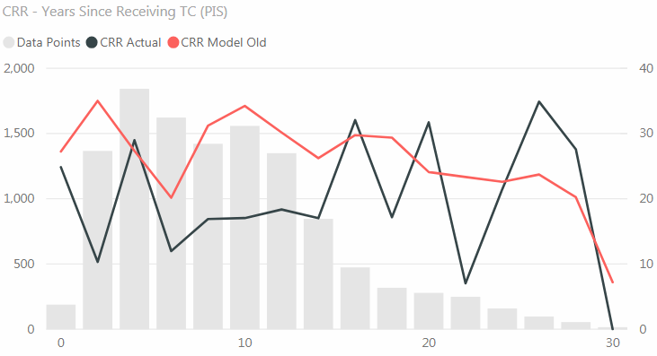
- Non-incentive-driven Prepay:
- Turnover (LP seeking financial return): Spike around LP’s exit (year 15)
  - Although most GPs retain ownership of their LIHTC properties at Year 15, a minority sells out (pp. 33 What happens...).
  - Under the terms of some partnership agreements, syndicators or investors may be able to insist on a third-party sale if they believe the property has value, even with extended use restrictions, in excess of its outstanding debt and more than the price the GP is willing to pay (pp. 33 What happens...)

- “Cash-out” (to pay for LP’s Exit): Spike around LP’s exit (year 15)
  - The GP refinanced in order to buy out the LPs (pp. 50 What happens...). the GP refinances at the same time as buying out the investors in the original syndication, because cash beyond the current mortgage is needed to meet the syndicator/LPs’ price (pp. 51 What happens...).

- Refi (for renovation): Not clear if the ramp differs from normal GPL loans.
  - Both continuing and new owners typically refinance at Year 15, and low interest rates have enabled them to fund modest renovations at Year 15 without recapitalizing with new tax credits (pp.xv What happens...).

- Combined Effect From Data:
  - Dataset #4: Actual CRR vs Years Since Receiving TC (filters: Negative Penalty-Adjusted Incentive)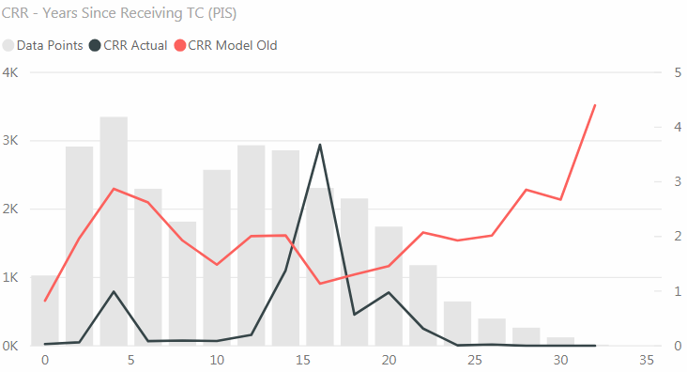

Difference between For-Profit / Non-Profit properties:
- Incentive-driven Prepay (Refi):
  - Refi: No evidence or obvious data pattern observed suggesting different refi behavior between the two.
  - Data Overview (filters: penalty-adjusted Incentive >= 0):
    - Dataset #5 (Non-Profit):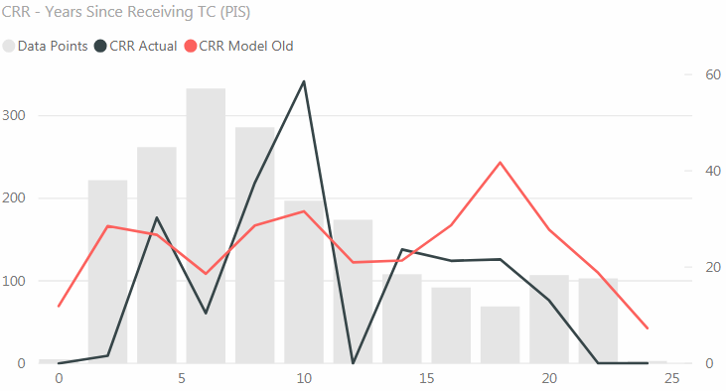
    - Dataset #6 (For-Profit):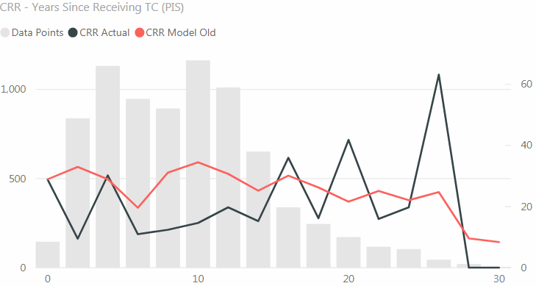

- Non-incentive-driven Prepay:
  - Data Overview: (filters: penalty-adjusted Incentive <= 0)
    - Dataset #5 (Non-Profit):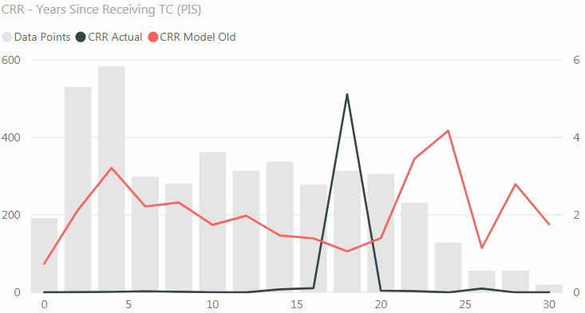
    - Dataset #6 (For-Profit):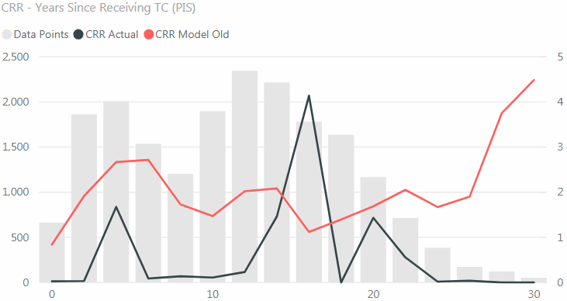
  - Turnover: Non-profit owners will have a much lower turnover CPR than for-profit buyers.
    - Almost always these are for-profit owners selling to for-profit buyers (pp.xiii). Only rarely do nonprofit owners sell their properties (pp.34 What happens…). Mission-driven owners—most nonprofit project sponsors, as well as some for-profit organizations—have an organizational plan that is to develop and own affordable housing long term (pp.32 What happens…).

    - Data Comparison (filters: Before year 12, penalty-adjusted Incentive <= 0):
      - Dataset #5 (Non-Profit):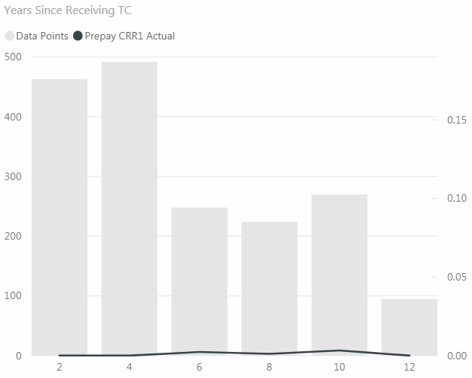
      - Dataset #6 (For-Profit):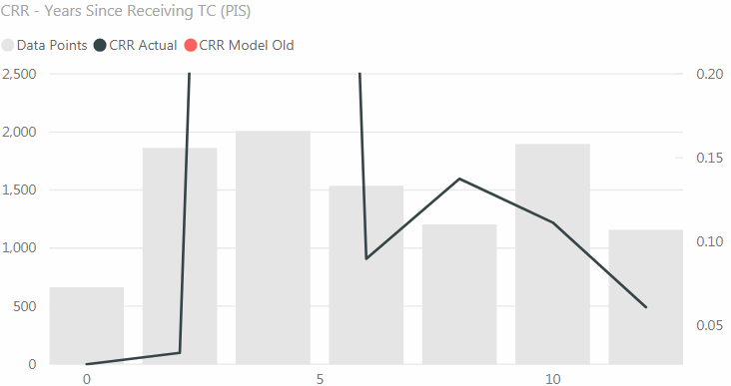

Model:
Method & Parameters
“Months Since Receiving TC”:
Based on the literature and data, we noticed that the depth into LIHTC (months since LIHTC) is an important parameter for predicting how loans with tax credit prepay, especially around year 15.

How to determine TC Start Date from indirect data: Point 1(b) from https://docs.google.com/document/d/1X_z5mgsO7G507e3fWOaQzibnoeQCn6E8wZx7ydlbvIc/edit

(//Todo) For loans without “conversion date” information,

“Profit/Non-Profit” flag: (//Todo)

Model & Tracking:
- Model A (for loans with TC date or CL conversion date known):
  - Overview:
This accounts for 81% of all the loans with LIHTC.
For this type of pools, the CL conversion Date tend to align with the TC start year (in years):
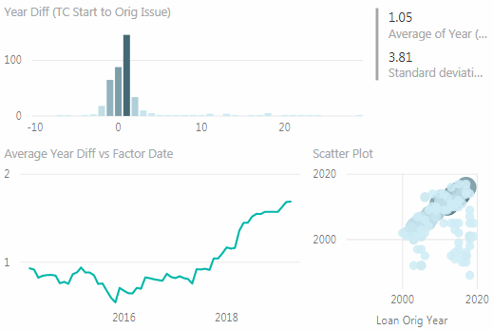

  - Model multipliers (months since CL conversion or TC start):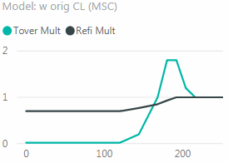

  - Tracking (Factor Date >= Feb 2016):
Overall (vs. penalty adjusted incentive):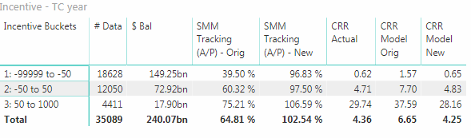
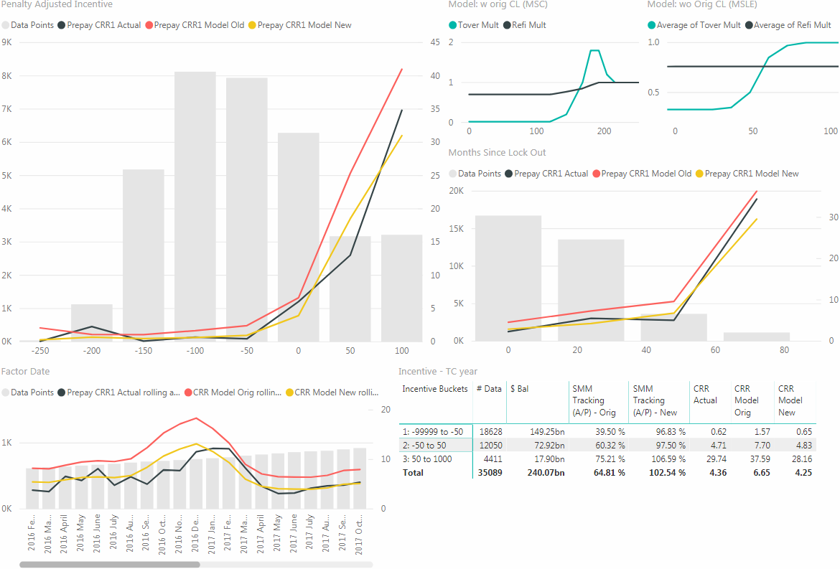

(vs. months since Conversion or TC start):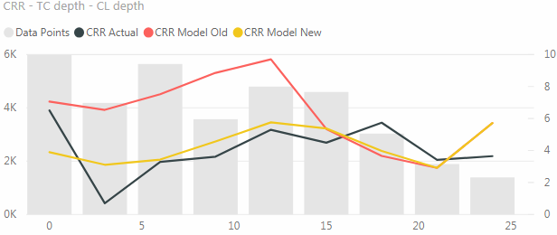

Out-of-money (incentive <= -50):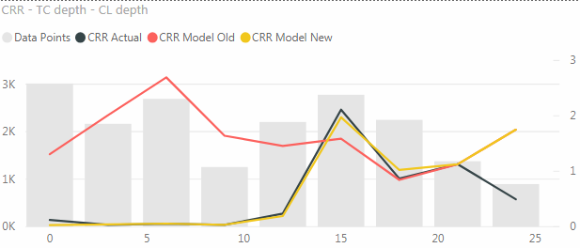
In-the-money (incentive >= 50):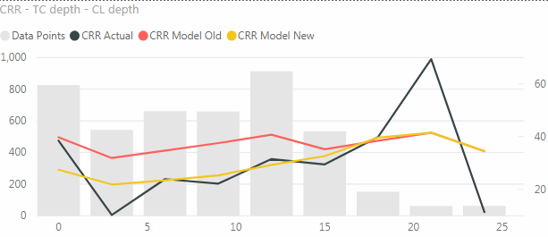

- Model B (for loans with TC date and CL conversion date unknown):
  - Overview:
No obvious pattern between the Issue Date of non-Construction loans and their TC start year (in years):
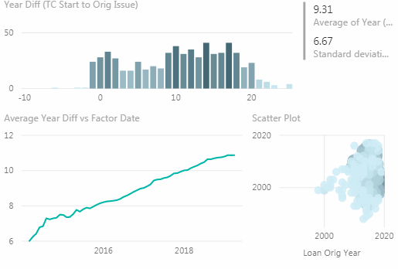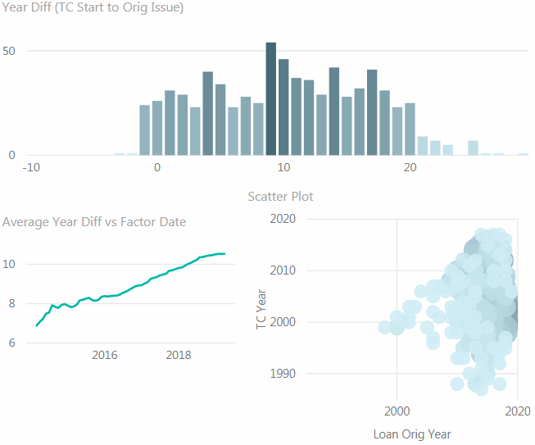

The average diff is 9.31 years, but the overall variance is big
S-curve comparison for (TC < 10yr vs. TC >= 10yr vs. Construction Loan), 0-48 msle, factor date > 2016-02-01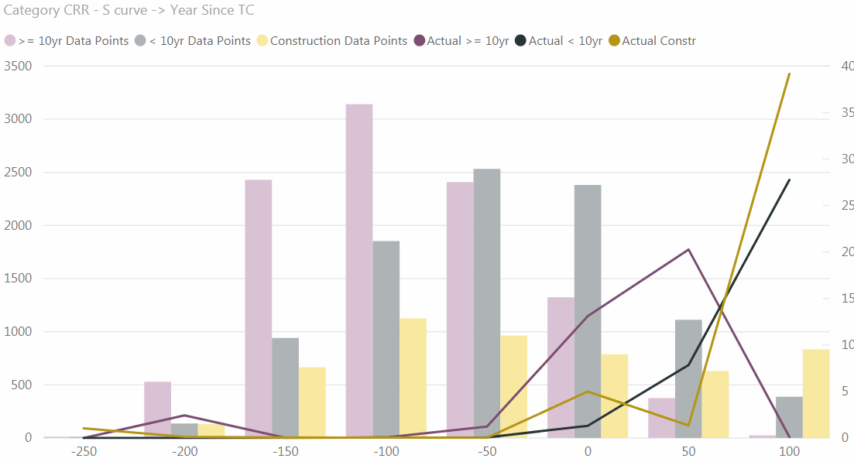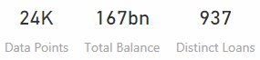

  - Model multipliers (months since lock-out end):
This model is fit with all LIHTC loan data, NOT restricted to the loans without “conversion date” and “TC start date”
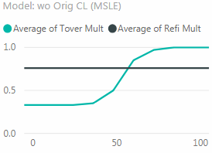
  - Tracking (Factor Date >= Feb 2016, for all LIHTC loans):
Overall (vs. penalty adjusted incentive):
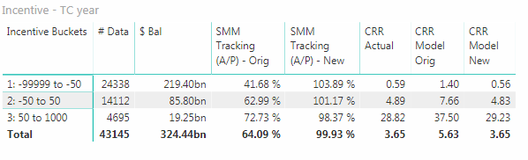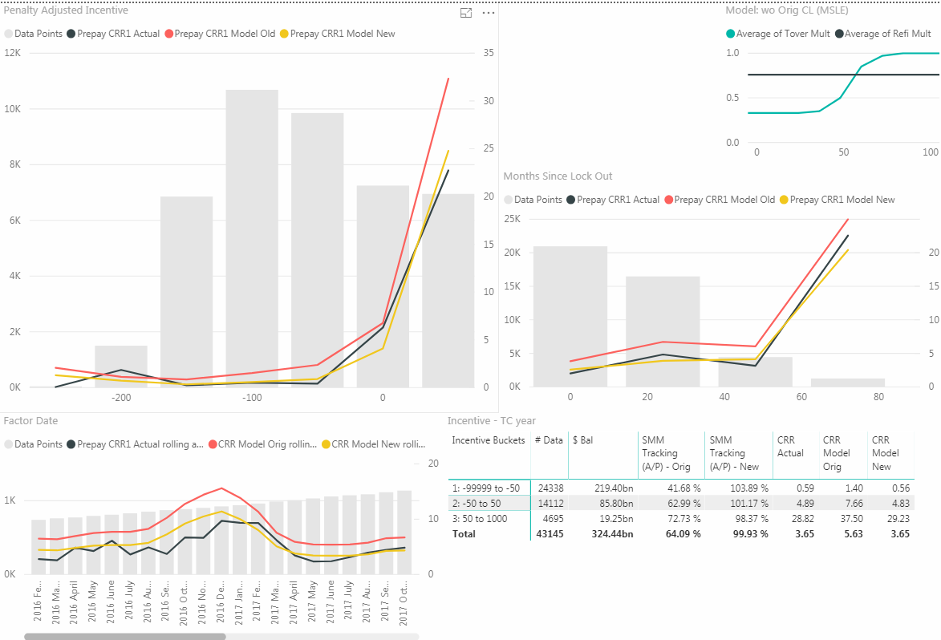

- Combined Model (All LIHTC Loans):
  - Overview:
For loans that we have “TC start date” information, or that we know the CL conversion date, we use Model A to project; for the rest of the loans, we use Model B
  - Result:
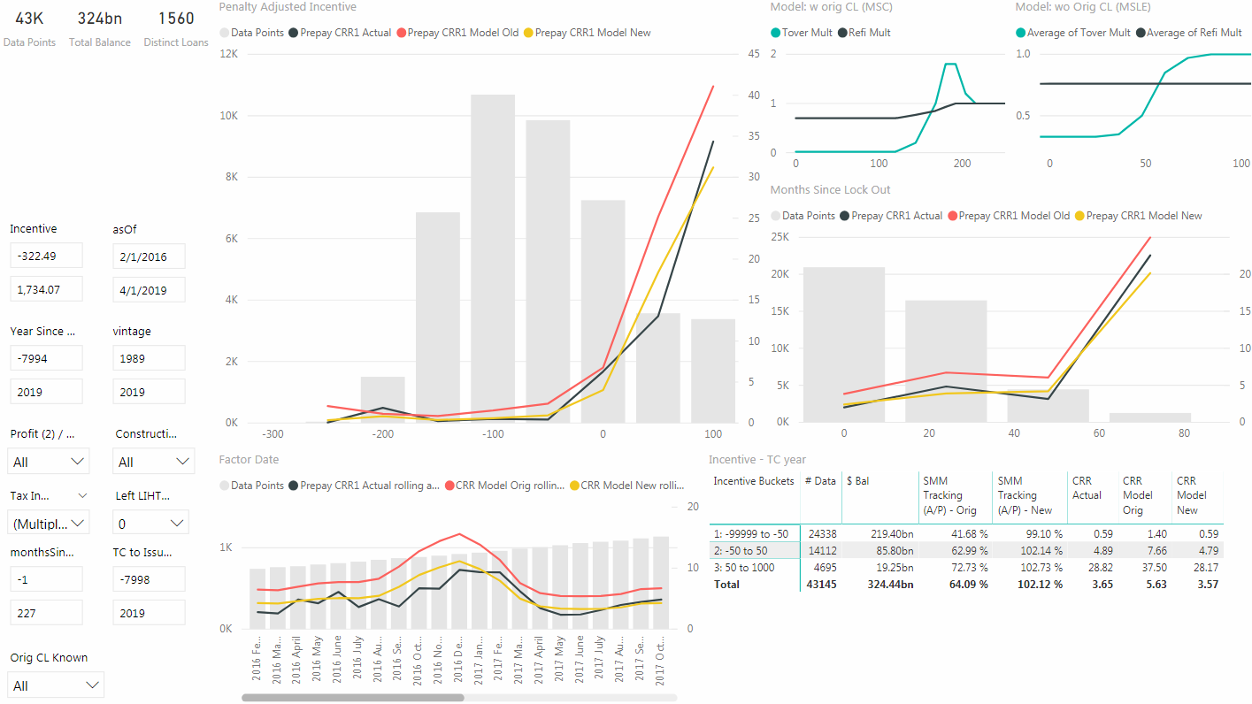

- Discussion on the impact of IRR/non-IRR prepayments:
  - https://docs.google.com/document/d/1sSbF7ZovukF9JL3glWjGZhnc3zhrGzde9mTjaxTNQIU/edit

The legislation that extended LIHTC use restrictions from 15 to 30 years also established a Qualified Contract (QC). In the QC process, the owner requests the state agency to find A buyer for the property, and the state agency then has one year to find a potential buyer who will maintain the property as affordable housing. If the state is unsuccessful in finding a buyer, then the owner is entitled to be relieved of LIHTC affordability restrictions, and those restrictions phase out over 3 years. QC sales tend to be concentrated in a few states and are not common.
Detailed discussion on this situation: https://docs.google.com/document/d/1J-i4f_0nQnb8wf_wEkuncPerISQh_tN1k-xkRb109NM/edit

